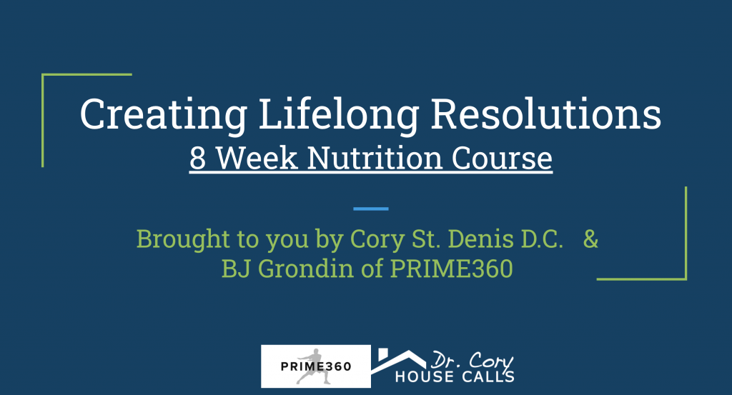
(example)
Goals and Success Sheet

Goal: I will be able to walk up and down the stairs without pain, pick up my grand children to play, and build health.

Why: (get deep)- I want to be able to play with my kids, I also want to be able to play pickup basketball at a high level and keep up with the younger crowd that comes.

Readiness to change scale: 8 of 10

Budget: An extra $100/week for myself, I will also stop drinking during the week to add an additional $20/week to my budget for health. This allows me to invest $120/week or $480/month toward my wellness!

